Project title : Collection Framework Method Implementation.
1. Aim / Objective
To implement and demonstrate the methods of Java Collection Framework classes, including List, Set, Queue, Deque, and Map implementations.
2. System Requirements
- Hardware: Computer with minimum 4 GB RAM.
- Software: Windows / Linux / Ubuntu.
- Language: Java.
- IDE: Eclipse / VS Code / Notepad.
- JDK: Java Development Kit 21.
3. Algorithm
- Start the program.
- Import the java.util package.
- Create an ArrayList and perform insertion, deletion, and retrieval operations.
- Create a LinkedList, Vector, and Stack and demonstrate their methods.
- Create HashSet, LinkedHashSet, and TreeSet to demonstrate unique elements and ordering.
- Create PriorityQueue and ArrayDeque and perform insertion and removal operations.
- Create HashMap, LinkedHashMap, TreeMap, and Hashtable to store key-value pairs.
- Perform operations such as add(), remove(), get(), put(), push(), and pop().
- Display the results of each collection.
- Stop the program.
4. UML Diagram
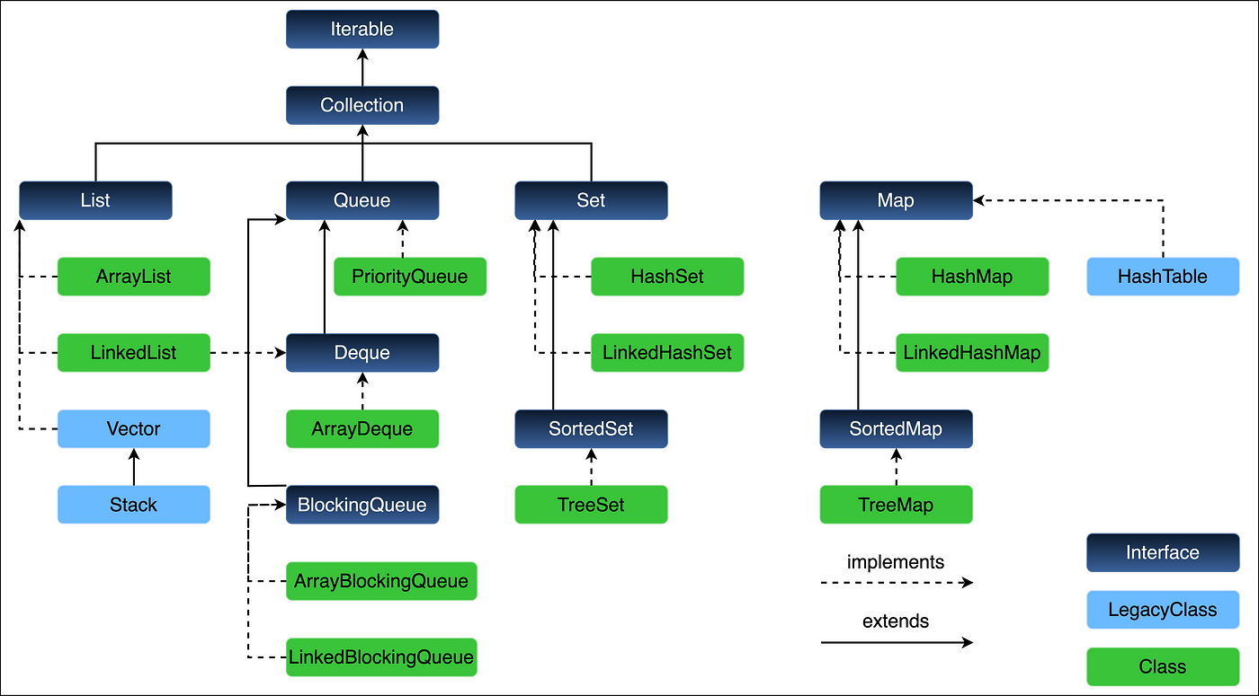
5. Source Code
import java.util.*;

public class Main {
public static void main(String[] args) {

ArrayList<Integer> al = new ArrayList<>(
Arrays.asList(10, 20, 30));
al.add(40);
al.remove(Integer.valueOf(20));
System.out.println("ArrayList: " + al);

LinkedList<String> ll = new LinkedList<>(
Arrays.asList("A", "B", "C"));
ll.addFirst("Start");
ll.addLast("End");
System.out.println("LinkedList: " + ll);

Vector<Integer> v = new Vector<>(
Arrays.asList(1, 2, 3));
v.add(4);
System.out.println("Vector: " + v);

Stack<Integer> st = new Stack<>();
st.push(10);
st.push(20);
st.push(30);
System.out.println("Stack: " + st);
System.out.println("Stack pop: " + st.pop());

HashSet<Integer> hs = new HashSet<>(
Arrays.asList(30, 10, 20, 10));
System.out.println("HashSet: " + hs);

LinkedHashSet<Integer> lhs = new LinkedHashSet<>(
Arrays.asList(30, 10, 20, 10));
System.out.println("LinkedHashSet: " + lhs);

TreeSet<Integer> ts = new TreeSet<>(
Arrays.asList(30, 10, 20, 10));
System.out.println("TreeSet: " + ts);

PriorityQueue<Integer> pq = new PriorityQueue<>(
Arrays.asList(30, 10, 20));
System.out.println("PriorityQueue: " + pq);
System.out.println("PriorityQueue poll: " + pq.poll());

ArrayDeque<Integer> dq = new ArrayDeque<>();
dq.addFirst(20);
dq.addLast(30);
dq.addFirst(10);
System.out.println("ArrayDeque: " + dq);
System.out.println("Deque remove: " + dq.removeFirst());

HashMap<Integer, String> hm = new HashMap<>();
hm.put(1, "Java");
hm.put(2, "Python");
hm.put(3, "C");
System.out.println("HashMap: " + hm);
System.out.println("HashMap get: " + hm.get(2));

LinkedHashMap<Integer, String> lhm =
new LinkedHashMap<>();
lhm.put(1, "Java");
lhm.put(2, "Python");
lhm.put(3, "C");
System.out.println("LinkedHashMap: " + lhm);

TreeMap<Integer, String> tm = new TreeMap<>();
tm.put(3, "C");
tm.put(1, "Java");
tm.put(2, "Python");
System.out.println("TreeMap: " + tm);

Hashtable<Integer, String> ht = new Hashtable<>();
ht.put(1, "Java");
ht.put(2, "Python");
ht.put(3, "C");
System.out.println("Hashtable: " + ht);
}
}
6. Compilation and Execution
Compile:
javac Main.java
Run:
java Main
7. Sample Output
Note: HashSet, HashMap, Hashtable, and PriorityQueue may display elements in a different order depending on their implementation.
ArrayList: [10, 30, 40]
LinkedList: [Start, A, B, C, End]
Vector: [1, 2, 3, 4]
Stack: [10, 20, 30]
Stack pop: 30
HashSet: [20, 10, 30]
LinkedHashSet: [30, 10, 20]
TreeSet: [10, 20, 30]
PriorityQueue: [10, 30, 20]
PriorityQueue poll: 10
ArrayDeque: [10, 20, 30]
Deque remove: 10
HashMap: {1=Java, 2=Python, 3=C}
HashMap get: Python
LinkedHashMap: {1=Java, 2=Python, 3=C}
TreeMap: {1=Java, 2=Python, 3=C}
Hashtable: {3=C, 2=Python, 1=Java}
8.output
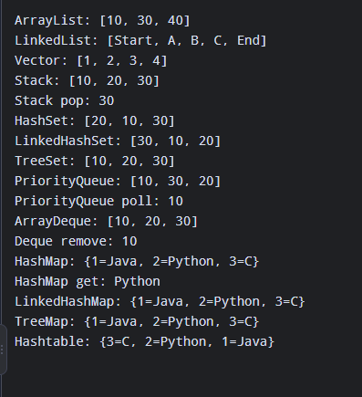
Result
Thus, the methods of the Java Collection Framework classes — ArrayList, LinkedList, Vector, Stack, HashSet, LinkedHashSet, TreeSet, PriorityQueue, ArrayDeque, HashMap, LinkedHashMap, TreeMap, and Hashtable — were successfully implemented and executed.

